 | 7.3.6 Editors - 3D Viewport - Sidebar - Tool Tab - Mesh - Sculpt Mode
Table of content
Detailed table of content 4
Tools Tab in Sculpt Mode 13
Brushes Panel 13
Custom Icon 13
Brush Settings Panel 14
Brush Settings Panel - Common Settings 14
Radius 14
Radius Unit 15
Strength 15
Front Faces Only 15
Normal Radius 15
Hardness 15
Autosmooth 15
Brush Settings Panel - Draw brush 16
Direction Add / Subtract 16
Brush Settings Panel - Draw Sharp brush 16
Direction Add / Subtract 16
Brush Settings Panel - Clay brush 16
Direction Add / Subtract 17
Plane Offset 17
Plane Trim 17
Brush Settings Panel - Clay Strip brush 17
Direction Add / Subtract 17
Plane Offset 17
Plane Trim 17
Tip roundness 18
Brush Settings Panel - Clay Thumb brush 18
Plane Offset 18
Plane Trim 18
Brush Settings Panel - Layer brush 19
Direction Add / Subtract 19
Height 19
Persistent 19
Brush Settings Panel - Inflate brush 19
Direction Inflate / Deflate 19
Brush Settings Panel - Blob brush 20
Direction Add / Subtract 20
Magnify 20
Brush Settings Panel - Crease brush 20
Direction Add / Subtract 20
Pinch 20
Brush Settings Panel - Smooth brush 21
Direction Smooth / Enhance 21
Brush Settings Panel - Flatten brush 21
Direction Contrast / Flatten 21
Plane Offset 21
Plane Trim 21
Brush Settings Panel - Fill brush 22
Direction Fill / Deepen 22
Plane Offset 22
Plane Trim 22
Area Radius 22
Invert to Scrape 22
Brush Settings Panel - Scrape brush 23
Direction Fill / Deepen 23
Plane Offset 23
Plane Trim 23
Area Radius 23
Invert to Fill 23
Brush Settings Panel - Multi-plane Scrape brush 24
Plane Angle 24
Dynamic Mode 24
Show Cursor Preview 24
Brush Settings Panel - Pinch brush 24
Direction Magnify / Pinch 24
Autosmooth 24
Brush Settings Panel - Grab brush 25
Normal Weight 25
Grab active Vertex 25
Grab Silhouette 25
Brush Settings Panel - Elastic Deform brush 25
Normal Weight 25
Deformation 25
Volume Preservation 26
Brush Settings Panel - Snake Hook brush 26
Normal Weight 26
Magnify 26
Rake 26
Deformation 26
Brush Settings Panel - Thumb brush 26
Brush Settings Panel - Pose brush 27
Deformation Target 27
Deformation 27
Rotation Origins 27
Pose Origin Offset 27
Smooth Iterations 27
Pose IK Segments 27
Keep Anchor Point 28
Connected only 28
Max Element Distance 28
Brush Settings Panel - Nudge brush 28
Brush Settings Panel - Rotate brush 28
Brush Settings Panel - Slide Relax brush 28
Deformation 28
Brush Settings Panel - Boundary brush 29
Deformation Target 29
Deformation 29
Boundary Falloff 29
Boundary Origin Offset 29
Brush Settings Panel - Cloth brush 30
Persistent 30
Simulation Area 30
Deformation 30
Force Falloff 31
Cloth Mass 31
Cloth Damping 31
Soft Body Influence 31
Enable Collision 31
Brush Settings Panel - Simplify brush 31
Brush Settings Panel - Mask brush 31
Direction Add / Subtract 32
Mask Tool 32
Brush Settings Panel - Draw Face Sets brush 32
Brush Settings Panel - Multires Displacement Eraser brush 32
Brush Settings Panel - Multires Displacement Smear brush 32
Deformation 32
Brush Settings Panel - Paint 33
Primary / Secondary color 33
Blend Mode 33
Flow 33
Wet Mix 33
Wet Persistence 34
Wet Paint Radius 34
Density 34
Tip Roundness 34
Tip Scale X 34
Brush Settings Panel - Smear 34
Deformation 35
Brush Settings Panel - Color Picker Sub panel 35
Mode 35
Brush Settings Panel - Color Palette Sub panel 38
Palette browser 38
Edit Box 38
Number of users 38
Fake User 38
Add palette 38
Remove Palette 38
Add color 38
Remove color 39
Sort By 39
Brush Settings Panel - Advanced Sub panel 39
Global Automasking (Header) 39
Automasking 39
Brush Settings Panel - Texture Subpanel 43
Brush Settings Panel - Stroke Sub panel 49
Stroke Panel with Stroke method Space 49
Stroke Panel with Stroke method Curve 51
Stroke Panel with Stroke method Line 53
Stroke Panel with Stroke method Airbrush 55
Stroke Panel with Stroke method Anchored 56
Stroke Panel with Stroke method Drag dot 57
Stroke Panel with Stroke method dot 57
Brush Settings Panel - Falloff Sub panel 58
Presets 59
Brush Settings Panel - Cursor Sub panel 60
Cursor checkbox in header 60
Cursor Color 60
Inverse Color 60
Falloff Opacity 61
Texture Opacity 61
Dyntopo Panel 61
Remesh Panel 63
Mode 63
Voxel Size 63
Adaptivity 63
Fix Poles 63
Smooth Normals 63
Preserve 64
Voxel Remesh / Quadriflow Remesh 64
Symmetry Panel 64
Mirror 64
Lock 64
Tiling 64
Feather 65
Radial 65
Tile Offset 65
Direction 65
Symmetrize 65
Merge Distance 65
Sculpt Mode - Options Panel 65
Display 65
Display 66
Gravity sub panel 66

Detailed table of content

Detailed table of content
Detailed table of content 4
Tools Tab in Sculpt Mode 13
Brushes Panel 13
Browse Brush 13
Custom Icon 13
Brush Settings Panel 14
Brush Settings Panel - Common Settings 14
Radius 14
Size Pressure 14
Use Unified Radius 14
Radius Unit 15
Strength 15
Size Pressure 15
Use Unified Radius 15
Front Faces Only 15
Normal Radius 15
Hardness 15
Invert Pressure for Hardness 15
Use pressure for hardness 15
Autosmooth 15
Use pressure for hardness 15
Brush Settings Panel - Draw brush 16
Direction Add / Subtract 16
Brush Settings Panel - Draw Sharp brush 16
Direction Add / Subtract 16
Brush Settings Panel - Clay brush 16
Direction Add / Subtract 17
Plane Offset 17
Plane Trim 17
Brush Settings Panel - Clay Strip brush 17
Direction Add / Subtract 17
Plane Offset 17
Plane Trim 17
Distance 18
Tip roundness 18
Brush Settings Panel - Clay Thumb brush 18
Plane Offset 18
Plane Trim 18
Distance 18
Brush Settings Panel - Layer brush 19
Direction Add / Subtract 19
Height 19
Persistent 19
Set Persistent Base 19
Brush Settings Panel - Inflate brush 19
Direction Inflate / Deflate 19
Brush Settings Panel - Blob brush 20
Direction Add / Subtract 20
Magnify 20
Brush Settings Panel - Crease brush 20
Direction Add / Subtract 20
Pinch 20
Brush Settings Panel - Smooth brush 21
Direction Smooth / Enhance 21
Brush Settings Panel - Flatten brush 21
Direction Contrast / Flatten 21
Plane Offset 21
Plane Trim 21
Brush Settings Panel - Fill brush 22
Direction Fill / Deepen 22
Plane Offset 22
Plane Trim 22
Area Radius 22
Size Pressure 22
Invert to Scrape 22
Brush Settings Panel - Scrape brush 23
Direction Fill / Deepen 23
Plane Offset 23
Plane Trim 23
Area Radius 23
Size Pressure 23
Invert to Fill 23
Brush Settings Panel - Multi-plane Scrape brush 24
Plane Angle 24
Dynamic Mode 24
Show Cursor Preview 24
Brush Settings Panel - Pinch brush 24
Direction Magnify / Pinch 24
Autosmooth 24
Brush Settings Panel - Grab brush 25
Normal Weight 25
Grab active Vertex 25
Grab Silhouette 25
Brush Settings Panel - Elastic Deform brush 25
Normal Weight 25
Deformation 25
Volume Preservation 26
Brush Settings Panel - Snake Hook brush 26
Normal Weight 26
Magnify 26
Rake 26
Deformation 26
Brush Settings Panel - Thumb brush 26
Brush Settings Panel - Pose brush 27
Deformation Target 27
Deformation 27
Lock Rotation when scaling 27
Rotation Origins 27
Pose Origin Offset 27
Smooth Iterations 27
Pose IK Segments 27
Keep Anchor Point 28
Connected only 28
Max Element Distance 28
Brush Settings Panel - Nudge brush 28
Brush Settings Panel - Rotate brush 28
Brush Settings Panel - Slide Relax brush 28
Deformation 28
Brush Settings Panel - Boundary brush 29
Deformation Target 29
Deformation 29
Boundary Falloff 29
Boundary Origin Offset 29
Brush Settings Panel - Cloth brush 30
Persistent 30
Set Persistent Base 30
Simulation Area 30
Simulation Limit 30
Simulation Falloff 30
Pin Simulation Boundary 30
Deformation 30
Force Falloff 31
Cloth Mass 31
Cloth Damping 31
Soft Body Influence 31
Enable Collision 31
Brush Settings Panel - Simplify brush 31
Brush Settings Panel - Mask brush 31
Direction Add / Subtract 32
Mask Tool 32
Brush Settings Panel - Draw Face Sets brush 32
Brush Settings Panel - Multires Displacement Eraser brush 32
Brush Settings Panel - Multires Displacement Smear brush 32
Deformation 32
Brush Settings Panel - Paint 33
Primary / Secondary color 33
Swap colors 33
Use Unified Color 33
Blend Mode 33
Flow 33
Invert Pressure 33
Use Pressure 33
Wet Mix 33
Invert Pressure 33
Use Pressure 34
Wet Persistence 34
Invert Pressure 34
Use Pressure 34
Wet Paint Radius 34
Density 34
Invert Pressure 34
Use Pressure 34
Tip Roundness 34
Tip Scale X 34
Brush Settings Panel - Smear 34
Deformation 35
Brush Settings Panel - Color Picker Sub panel 35
Mode 35
Color / Gradient 35
Color picker mode 35
Colorpicker 35
Primary / Secondary color 35
Swap colors 35
Use Unified Color 35
Gradient mode 35
Color Ramp 35
Controls 36
+ 36
- 36
Tools menu 36
Flip Color Ramp 36
Distribute Stops from Left 36
Distribute Stops Evenly 36
Eyedropper (pipette icon) E 36
Reset Color Ramp 36
Color Mode 36
RGB 36
HSV/HSL 36
Interpolation 36
Ease 36
Cardinal 36
Linear 36
B-Spline 36
Constant 36
Color Ramp 37
Active Color Stop elements 37
Choose active color stop 37
Pos 37
Color 37
Background Color 37
Gradient Mapping 37
Pressure 37
Repeat 37
Gradient Spacing 37
Clamp 37
Gradient Spacing 37
Brush Settings Panel - Color Palette Sub panel 38
Palette browser 38
Edit Box 38
Number of users 38
Fake User 38
Add palette 38
Remove Palette 38
Add color 38
Remove color 39
Sort By 39
Brush Settings Panel - Advanced Sub panel 39
Global Automasking (Header) 39
Automasking 39
Topology 40
Face Sets 40
Mesh Boundary 40
Face Sets Boundary 40
Cavity 40
Cavity (Inverted) 40
Create Mask 40
Factor 40
Blur 40
Custom Curve 40
Selecting Points 41
Adding Points 41
Navigation elements 41
Zoom in and out 41
Clipping Options 41
Use Clipping 41
Min and Max X Y 41
Tools 41
Reset View 41
Extend horizontal 41
Extend extrapolated 41
Reset Curve 41
Handle Types 42
X Y Position 42
Delete Points 42
View Normal 42
Occlusion 42
Limit 42
Falloff 42
Area Normal 42
Limit 42
Falloff 42
Sculpt Plane 42
Use Original 43
Normal 43
Plane 43
Accumulate 43
Front Faces Only 43
Brush Settings Panel - Texture Subpanel 43
Browse Texture to be linked 43
Adding a texture 43
Texture Edit box 44
Brush Mapping 44
Brush Mapping with mapping method View Plane and Area Plane 45
Angle edit box 45
Rake 45
Random 45
Random edit box 45
Offset 46
Size 46
Sample Bias 46
Vector Displacement 46
Brush Mapping with mapping method Tiled 46
Angle edit box 46
Offset 46
Size 46
Sample Bias 47
Brush Mapping with mapping method 3D 47
Offset 47
Size 47
Sample Bias 47
Brush Mapping with mapping method Random 47
Angle edit box 48
Rake 48
Random 48
Random edit box 48
Offset 48
Size 48
Sample Bias 48
Brush Mapping with mapping method Stencil 48
Image Aspect 49
Angle edit box 49
Offset 49
Stencil Texture Controls 49
Brush Settings Panel - Stroke Sub panel 49
Stroke Panel with Stroke method Space 49
Spacing Edit Box 50
Spacing Pressure 50
Spacing Distance 50
Adjust Strength for Spacing 50
Dash Ratio 50
Dash Length 50
Jitter Edit Box 50
Jitter Pressure 51
Jitter Unit 51
Input Samples Edit Box 51
Stabilize Stroke 51
Smooth Stroke Radius Edit Box 51
Smooth Stroke Factor Edit Box 51
Stroke Panel with Stroke method Curve 51
Spacing Edit Box 52
Spacing Distance 52
Adjust Strength for Spacing 52
Paint Curve edit box 52
Draw Curve Button 53
Jitter Edit Box 53
Jitter Pressure 53
Jitter Unit 53
Input Samples Edit Box 53
Stroke Panel with Stroke method Line 53
Spacing Edit Box 54
Spacing Distance 54
Adjust Strength for Spacing 54
Jitter Edit Box 54
Jitter Pressure 54
Jitter Unit 54
Input Samples Edit Box 54
Stroke Panel with Stroke method Airbrush 54
Rate Edit Box 55
Spacing Distance 55
Jitter Edit Box 55
Jitter Pressure 55
Jitter Unit 55
Input Samples Edit Box 55
Stabilize Stroke 55
Smooth Stroke Radius Edit Box 55
Smooth Stroke Factor Edit Box 56
Stroke Panel with Stroke method Anchored 56
Edge to Edge 56
Spacing Distance 56
Input Samples Edit Box 56
Stroke Panel with Stroke method Drag dot 56
Spacing Distance 56
Input Samples Edit Box 57
Stroke Panel with Stroke method dot 57
Spacing Distance 58
Jitter Edit Box 58
Jitter Unit 58
Input Samples Edit Box 58
Stabilize Stroke 58
Smooth Stroke Radius Edit Box 58
Smooth Stroke Factor Edit Box 58
Brush Settings Panel - Falloff Sub panel 58
Presets 58
Selecting Points 59
Adding Points 59
Navigation elements 59
Zoom in and out 59
Tools 59
Reset View 59
Vector Handle 59
Auto Handle 59
Auto Clamped Handle 59
Reset Curve 59
Use Clipping 60
Delete Points 60
Curve Presets 60
Falloff Shape 60
Brush Settings Panel - Cursor Sub panel 60
Cursor checkbox in header 60
Cursor Color 60
Inverse Color 60
Falloff Opacity 60
Override Overlay 60
Use Cursor Overlay 60
Texture Opacity 61
Override Overlay 61
Use Cursor Overlay 61
Dyntopo Panel 61
Detailing 61
Relative Detail 61
Brush Detail 61
Constant Detail 62
Manual Detail 62
Refine method 62
Subdivide Collapse 62
Collapse Edges 62
Subdivide Edges 62
Resolution 62
Sample detail size picker 62
Set Detail Size / Set Detail Percentage 62
Detail Flood Fill 63
Remesh Panel 63
Mode 63
Voxel Size 63
Sample Detail Size 63
Adaptivity 63
Fix Poles 63
Smooth Normals 63
Preserve 63
Volume 63
Attributes 64
Voxel Remesh / Quadriflow Remesh 64
Symmetry Panel 64
Mirror 64
Lock 64
Tiling 64
Feather 64
Radial 65
Tile Offset 65
Direction 65
Symmetrize 65
Merge Distance 65
Sculpt Mode - Options Panel 65
Display 65
Fast Navigate 65
Delay Viewport Updates 65
Use Deform only 65
Display 66
Topology 66
Face Sets 66
Mesh Boundary 66
Face Sets Boundary 66
Cavity 66
Cavity ( Inverted) 66
Area Normal 66
View Normal 66
Propagation Steps 66
Gravity sub panel 66
Factor 66
Orientation 66

Tools Tab in Sculpt Mode

Sculpting is a process to deform the geometry by using a brush. Mesh objects, Grease Pencil objects and Hair Curve objects can be sculpted. In this chapter we handle the mesh tools. Grease Pencil and Curve Objects have their own chapter.
In Sculpt Mode you will mainly find settings for the different brushes, General settings, and brush specific settings. This settings can be found in different panels. The different brushes have different options and settings, dependent of which brush is selected. This brush specific options and settings are explained in the tool shelf chapter. Here we just cover the general panels with options and settings that exists for (nearly) all brushes.
The Sculpt Mode just exists for Mesh, Grease Pencil and Hair Curve objects.

Brushes Panel
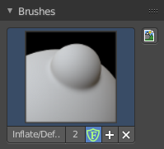
The Brush Panel contains an image browser to display the different Sculpt Brushes. Usually you have just one icon when you choose a brush from the tool shelf. But you can create your own brushes, based at the current chosen brush type. They save with the blend file when fake user is ticked.

Browse Brush
The big image at the top is a drop down box where you can see the currently active brush. The file browser just shows the current active brush. Which gets chosen in the 3d view in the tool shelf. You can duplicate this brush, and modify it to your needs.
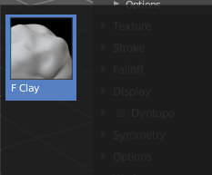
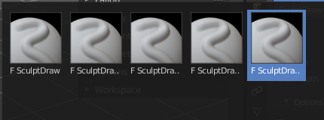
When you have added a few more brushes then the drop down box may be more than full. You will see some little white arrows then. Either in the top left or in the bottom right corner. They indicate that some brushes are hidden before or after the current display.
To scroll to this hidden content use the mouse wheel, or the arrow up and down buttons at the keyboard.

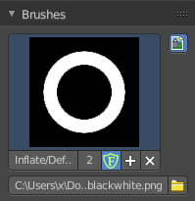
Custom Icon
The button at the right allows you to load a custom icon for your brush. It reveals a file browser below the image browser.

The edit box below the Image shows you the name of the current active brush.
The number right of it, in this case 2, indicates how much number of users ( internally ) this brush uses. This means that this data block (the brush) shares currently settings with at least one other object. Most probably the parent brush where we have created it from. Click at the value to make this brush a single user. The button will vanish then.
F set the brush to have a fake user. Zero user data-blocks are normally not saved. But sometimes you want to force the data to be kept even when the data block has no user.
The + button allows you to add a new pencil with the current settings. Note that the brushes are NOT saved when you close Bforartists. You can save them into the current blend file. Or you can save the startup file. But be careful here. This saves everything else of the current state of Bforartists too.
The X button deletes the brush as the active one. It does NOT delete it from the brushes list.

Brush Settings Panel
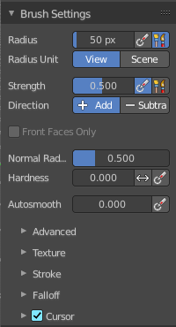
The Brush Settings Panel contains the Brush settings. The content differs, dependent of which brush you have chosen.

Brush Settings Panel - Common Settings

These settings can be found in all brushes.

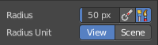
Radius
The Radius edit box allows you to adjust the radius of the brush.

Size Pressure
The first button behind the edit box enables tablet pressure sensitivity for radius.

Use Unified Radius
The second button behind the edit box enables global radius size. Any modification at the radius will also modify the radius value for other paint tools.

Radius Unit
Display the radius value in view units or in scene units. View units are by default in pixels, scene units in meters.

Strength
The Strength edit box allows you to adjust the strength of the brush.

Size Pressure
The first button behind the edit box enables tablet pressure sensitivity for radius.

Use Unified Radius
The second button behind the edit box enables global radius size. Any modification at the radius will also modify the radius value for other paint tools.

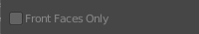
Front Faces Only
Front Faces only means that the stroke just affects the vertices that are pointing forwards to the camera.
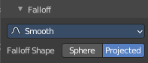
You need to have the fallof method set to Projected to activate the Front Faces Only checkbox.

Normal Radius
The ratio between the brush radius and the radius that is going to be used to sample the normal.

Hardness
How close the brush fallow starts from the edge of the brush.

Invert Pressure for Hardness
Invert the modulation of pressure in hardness.

Use pressure for hardness
Tablet feature. Use pressure to modulate hardness.

Autosmooth
The autosmooth edit box allows you to adjust the amount of smoothing that gets automatically applied to each stroke.

Use pressure for hardness
Tablet feature. Use pressure to modulate hardness.

Brush Settings Panel - Draw brush
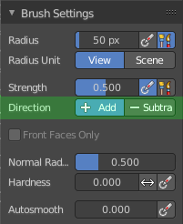

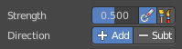
Direction Add / Subtract
Add means the stroke adds to the geometry. Subtract means the stroke subtracts from the geometry.

Brush Settings Panel - Draw Sharp brush

Direction Add / Subtract
Add means the stroke adds to the geometry. Subtract means the stroke subtracts from the geometry.

Brush Settings Panel - Clay brush
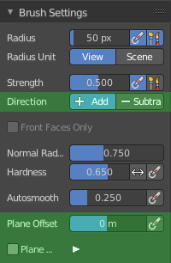

Direction Add / Subtract
Add means the stroke adds to the geometry. Subtract means the stroke subtracts from the geometry.

Plane Offset
Adjust the plane on which the brush acts towards or away from the objects surface. Sculpting with the Clay brush happens in a plane defined by the view you are in and the first vertices hit by the brush.

Plane Trim
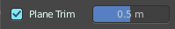
Various brushes like Clay, Clay Thumb, Fill and Scrape brush. Enable Plane Trim. Sculpting with these brushes happens in a plane defined by the view you are in and the first vertices hit by the brush. The trim distance defines a limit above which vertices are not affected by the brush.

Brush Settings Panel - Clay Strip brush
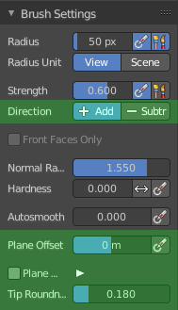

Direction Add / Subtract
Add means the stroke adds to the geometry. Subtract means the stroke subtracts from the geometry.

Plane Offset
Adjust the plane on which the brush acts towards or away from the objects surface. Sculpting with the Clay brush happens in a plane defined by the view you are in and the first vertices hit by the brush.

Plane Trim
Various brushes like Clay, Clay Thumb, Fill and Scrape brush. Enable Plane Trim. Sculpting with these brushes happens in a plane defined by the view you are in and the first vertices hit by the brush. The trim distance defines a limit above which vertices are not affected by the brush.

Distance
Adjust the plane trim distance.

Tip roundness
Roundness of the brush tip.

Brush Settings Panel - Clay Thumb brush
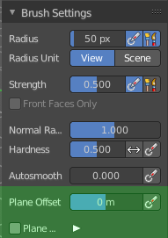

Plane Offset
Adjust the plane on which the brush acts towards or away from the objects surface. Sculpting with the Clay brush happens in a plane defined by the view you are in and the first vertices hit by the brush.

Plane Trim
Various brushes like Clay, Clay Thumb, Fill and Scrape brush. Enable Plane Trim. Sculpting with these brushes happens in a plane defined by the view you are in and the first vertices hit by the brush. The trim distance defines a limit above which vertices are not affected by the brush.

Distance
Adjust the plane trim distance.

Brush Settings Panel - Layer brush
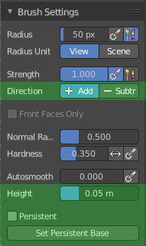

Direction Add / Subtract
Add means the stroke adds to the geometry. Subtract means the stroke subtracts from the geometry.

Height
Layer brush setting. The height that can be affected by the layer brush.

Persistent
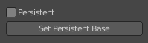
Layer brush setting. Sculpt on a persistent layer of the mesh.

Set Persistent Base
This button resets the base so that you can add another layer.

Brush Settings Panel - Inflate brush
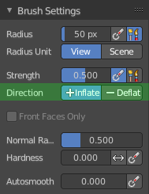

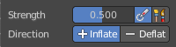
Direction Inflate / Deflate
Add or subtract effect of the brush.

Brush Settings Panel - Blob brush
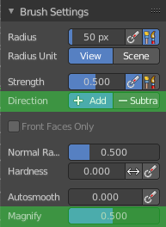

Direction Add / Subtract
Add means the stroke adds to the geometry. Subtract means the stroke subtracts from the geometry.

Magnify
The Crease Brush Pinch Factor.

Brush Settings Panel - Crease brush
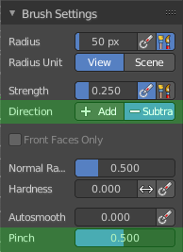

Direction Add / Subtract
Add means the stroke adds to the geometry. Subtract means the stroke subtracts from the geometry.

Pinch
The Crease Brush Pinch Factor.

Brush Settings Panel - Smooth brush
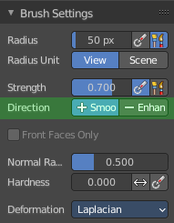

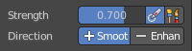
Direction Smooth / Enhance
Smooth or enhance the surface detail.

Brush Settings Panel - Flatten brush
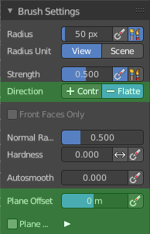

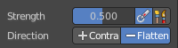
Direction Contrast / Flatten
Give more contrast or smooth the surface.

Plane Offset
Adjust the plane on which the brush acts towards or away from the objects surface. Sculpting with the Clay brush happens in a plane defined by the view you are in and the first vertices hit by the brush.

Plane Trim
Enable Plane Trim. Sculpting with these brushes happens in a plane defined by the view you are in and the first vertices hit by the brush. The trim distance defines a limit above which vertices are not affected by the brush.

Brush Settings Panel - Fill brush
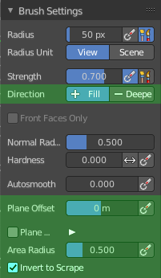

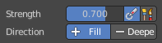
Direction Fill / Deepen
Add or subtract effect of the brush

Plane Offset
Adjust the plane on which the brush acts towards or away from the objects surface. Sculpting with the Clay brush happens in a plane defined by the view you are in and the first vertices hit by the brush.

Plane Trim
Enable Plane Trim. Sculpting with these brushes happens in a plane defined by the view you are in and the first vertices hit by the brush. The trim distance defines a limit above which vertices are not affected by the brush.

Area Radius
The ratio between the brush radius and the radius that is going to be used to sample the area center.

Size Pressure
Enables tablet pressure sensitivity for radius.

Invert to Scrape
Invert the stroke to a scrape stroke. Does not invert the displacement direction.

Brush Settings Panel - Scrape brush
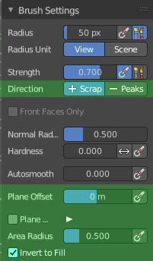

Direction Fill / Deepen
Add or subtract effect of the brush.

Plane Offset
Adjust the plane on which the brush acts towards or away from the objects surface. Sculpting with the Clay brush happens in a plane defined by the view you are in and the first vertices hit by the brush.

Plane Trim
Enable Plane Trim. Sculpting with these brushes happens in a plane defined by the view you are in and the first vertices hit by the brush. The trim distance defines a limit above which vertices are not affected by the brush.

Area Radius
The ratio between the brush radius and the radius that is going to be used to sample the area center.

Size Pressure
Enables tablet pressure sensitivity for radius.

Invert to Fill
Use scrape or fill tool when inverting this brush instead of inverting its displacement direction.

Brush Settings Panel - Multi-plane Scrape brush
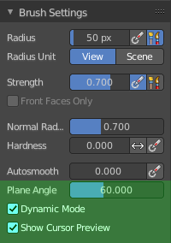

Plane Angle
Multiplane Scrape brush. The angles between the planes of the crease.

Dynamic Mode
Multiplane Scrape brush. Fit the angles during the stroke to fit the angles under the cursor.

Show Cursor Preview
Multiplane Scrape brush. Preview the plane scrapes in the cursor during the stroke.

Brush Settings Panel - Pinch brush
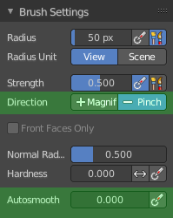

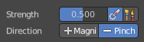
Direction Magnify / Pinch
Add or subtract effect of the brush.

Autosmooth
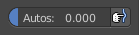
The autosmooth edit box allows you to adjust the amount of smoothing that gets automatically applied to each stroke. The button behind the edit box enables tablet pressure sensitivity for autosmooth.

Brush Settings Panel - Grab brush
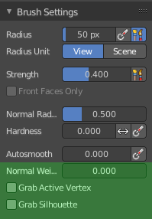

Normal Weight
How much grab will pull vertexes out of surface during grab.

Grab active Vertex
Apply the maximum grab strength to the active vertex instead of the cursor position.

Grab Silhouette
Grab trying to automask the silhouette of the object.

Brush Settings Panel - Elastic Deform brush
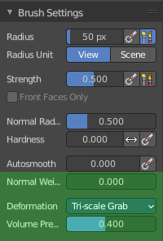

Normal Weight
How much grab will pull vertexes out of surface during grab.

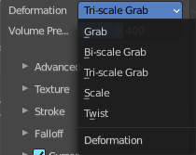
Deformation
The deformation type to use.

Volume Preservation
Poisson ratio for elastic deform. The higher the value is the more the volume is kept. But leads to more bulging.

Brush Settings Panel - Snake Hook brush
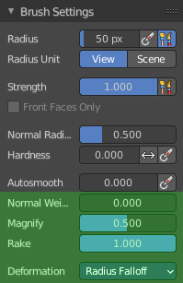

Normal Weight
How much grab will pull vertexes out of surface during grab.

Magnify
The Crease Brush Pinch Factor.

Rake
How much grab will follow cursor rotation.

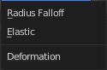
Deformation
The deformation type.

Brush Settings Panel - Thumb brush
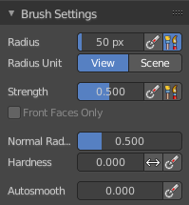
Just standard settings.

Brush Settings Panel - Pose brush
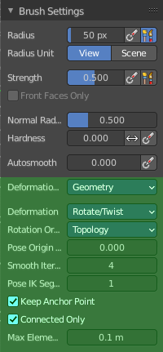

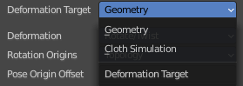
Deformation Target
Pose Brush setting. How the deformation of the brush will affect the object.

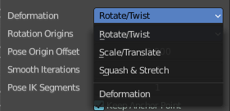
Deformation
Pose Brush setting. Deformation type that is used in the brush.

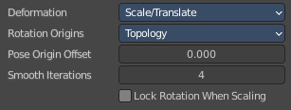
Lock Rotation when scaling
With Scale/Translate mode. Do not rotate the segment when using the scale deform mode.

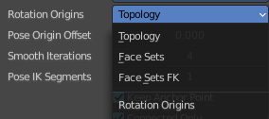
Rotation Origins
Pose Brush setting. Define the rotation origins.

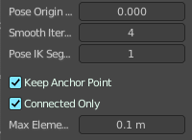
Pose Origin Offset
Pose Brush setting. Offset of the pose origin in relation to the brush radius.

Smooth Iterations
Pose Brush setting. Smooth iterations applied after calculating the pose factor of each vertex.

Pose IK Segments
Pose Brush setting. Number of segments of the IK chain that will deform the mesh.

Keep Anchor Point
Pose Brush setting. Keep the position of the last segment in the IK chain fixed.

Connected only
Affect only topology connected elements.

Max Element Distance
Maximum distance to search for disconnected loose parts in the mesh.

Brush Settings Panel - Nudge brush
Just standard settings.

Brush Settings Panel - Rotate brush
Just standard settings.

Brush Settings Panel - Slide Relax brush
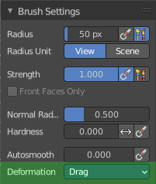

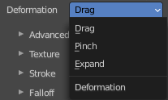
Deformation
The deformation type to use.

Brush Settings Panel - Boundary brush
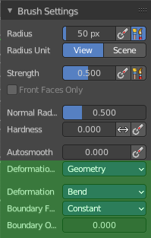

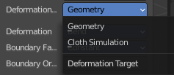
Deformation Target
The deformation type to use.

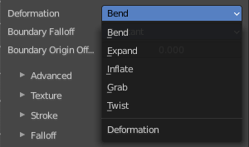
Deformation
The deformation type to use.

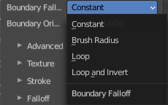
Boundary Falloff
Boundary brush option. The falloff type.

Boundary Origin Offset
Boundary brush option. Offset of the boundary origin in relation to the brush radius.

Brush Settings Panel - Cloth brush
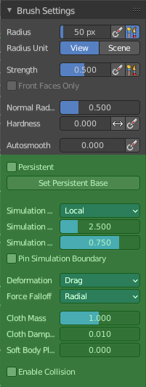

Persistent
Layer brush setting. Sculpt on a persistent layer of the mesh.

Set Persistent Base
This button resets the base so that you can add another layer.

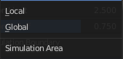
Simulation Area
Cloth brush. Simulates either only a specific area around the brush or the entire mesh.

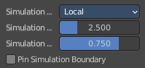
Simulation Limit
Cloth brush with local area. Factor added relative to the size of the radius. To limit the cloth simulation effect.

Simulation Falloff
Cloth brush with local area. The area to apply deformation falloff to the effects of the simulation.

Pin Simulation Boundary
Lock the position of the vertices in the simulation falloff area.

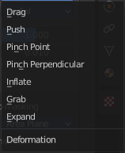
Deformation
Cloth brush. The type of cloth deformation that you want to perform.

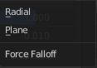
Force Falloff
Cloth brush. The shape that is used in the brush to apply force to the cloth.

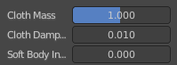
Cloth Mass
Cloth brush. The mass of each simulation particle.

Cloth Damping
Cloth brush. How much the applied forces are propagated through the cloth.

Soft Body Influence
Cloth brush. How much the simulation preserves the original shape, acting as a soft body.

Enable Collision
Cloth brush. Collide with objects during the simulation.

Brush Settings Panel - Simplify brush
Just standard settings.

Brush Settings Panel - Mask brush
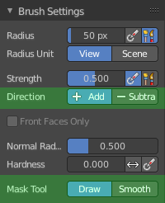

Direction Add / Subtract
Add means the stroke adds to the geometry. Subtract means the stroke subtracts from the geometry.

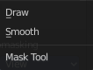
Mask Tool
Draw or smooth the current mask.

Brush Settings Panel - Draw Face Sets brush
Just standard settings.

Brush Settings Panel - Multires Displacement Eraser brush
Just standard settings.

Brush Settings Panel - Multires Displacement Smear brush
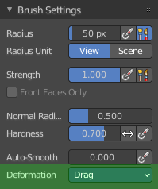

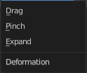
Deformation
The deformation method for the smear.

Brush Settings Panel - Paint
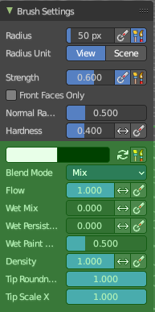
Paint allows you to vertex paint at the sculpt mesh.

Primary / Secondary color
Set the primary and secondary color for painting.

Swap colors
Swap the primary with the secondary color.

Use Unified Color
Use the same color over all editors and modes.

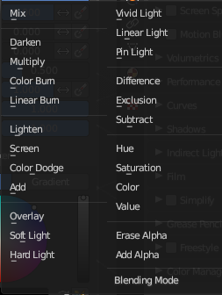
Blend Mode
The blending mode for the color.

Flow
Amount of paint applied per stroke sample.

Invert Pressure
Invert pressure.

Use Pressure
Use Pressure. This requires a tablet.

Wet Mix
Mix the existing color into the paint color.

Invert Pressure
Invert pressure.

Use Pressure
Use Pressure. This requires a tablet.

Wet Persistence
Amount of wet paint that stays at the stroke after applying paint to the surface.

Invert Pressure
Invert pressure.

Use Pressure
Use Pressure. This requires a tablet.

Wet Paint Radius
Ratio between the brush radius and the radius that gots used for wet paint.

Density
Amount of random elements that are going to be affected by the brush.

Invert Pressure
Invert pressure.

Use Pressure
Use Pressure. This requires a tablet.

Tip Roundness
Roundness of the brush tip.

Tip Scale X
Scale of the brush tip in X axis.

Brush Settings Panel - Smear
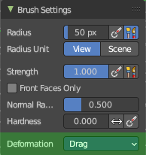
Smear vertex colors.

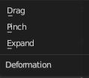
Deformation
How to deform the smearing.

Brush Settings Panel - Color Picker Sub panel
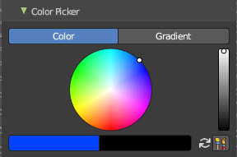
This sub panel is for the vertex painting paint tool. Define the primary and secondary color for the paint by a color picker and gradient dialog.

Mode

Color / Gradient
Choose the color mode.

Color picker mode

Colorpicker
The color wheel of the color picker.

Primary / Secondary color
Set the primary and secondary color for painting.

Swap colors
Swap the primary with the secondary color.

Use Unified Color
Use the same color over all editors and modes.

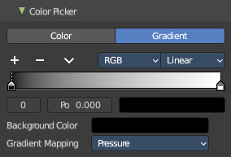
Gradient mode
Allows you to paint gradients.

Color Ramp
Color Ramps enables the user to specify a range of colors based on color stops. The color between the color stops gets interpolated.

Controls

+
Add a stop to your color ramp. The stop will be added after the selected one, in the middle to the next one.

-
Deletes the selected color stop from the list.


Tools menu

Flip Color Ramp
Flips the gradient, inverting the values of the color ramp.

Distribute Stops from Left
Rearrange the stops so that every step has the same space to the right.

Distribute Stops Evenly
Space between all neighboring stops becomes equal.

Eyedropper (pipette icon) E
An Eyedropper to sample a color or gradient from the interface to be used in the color ramp.

Reset Color Ramp

Resets the color ramp to its default state.

Color Mode

RGB
Blends color by mixing each color channel and combining.

HSV/HSL
Blends colors by first converting to HSV or HSL, mixing, then combining again. This has the advantage of maintaining saturation between different hues, where RGB would de-saturate, this allows for a richer gradient.


Interpolation

Ease
Uses an Ease Interpolation for the color stops.

Cardinal
Uses a Cardinal Interpolation for the color stops.

Linear
Uses a Linear Interpolation for the color stops.

B-Spline
Uses a B-Spline Interpolation for the color stops.

Constant
Uses a Constant Interpolation for the color stops.

Color Ramp
The color band. A click at one of the color stops makes it the active one. You can move the color stops by clicking at them and dragging them around.

Active Color Stop elements
Adjust the active color stop.

Choose active color stop
Choose the color stop by index.

Pos
The position of the active color stop. The range goes from 0.000 to 1.000

Color
The color of the active color stop. Click at it to change the color.

Background Color
The background color.

Gradient Mapping
How to paint the gradient.

Pressure
Paint the gradient by tablet pressure. Obviously you need a tablet for this.

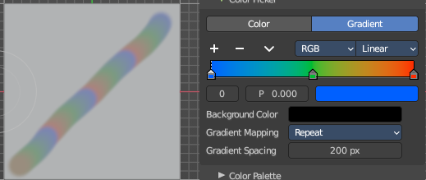
Repeat
Paint the gradient by repeating the colors.

Gradient Spacing
The spacing between the colors in screen pixels. You need to have a gradient spacing higher than 0.

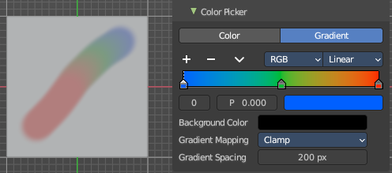
Clamp
Paint the gradient from first color to last color, and then sticks with the last color. You need to have a gradient spacing higher than 0.

Gradient Spacing
The spacing between the colors in screen pixels.

Brush Settings Panel - Color Palette Sub panel
This sub panel just shows with the paint tool. Define a color palette to use for vertex painting.
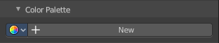
Create a color palette for later reuse.
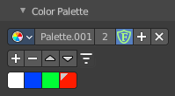
First create a new palette by clicking at New. Then adjust the color in the color picker. And then click at the add button to add this color to the palette.
To set the color picker to a palette color simply click at this palette color.
To remove a color from the palette, choose it, then click at the remove button. The active palette color that gets removed is the one with the triangle at it.
The color palette cannot be saved externally. It is part of the current blend file. You can however append color palettes from other blend files.
The currently active color is the one with the triangle at it.
The elements are explained from left to right.

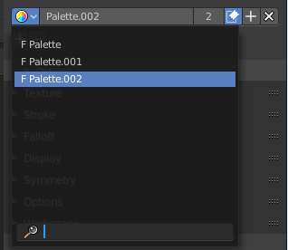
Palette browser
The button at the left opens a dropdown list. Choose between your palettes.

Edit Box
The name of the currently active palette. You can also rename the palette here. A click into the edit box makes the name editable.

Number of users
See how many users the palette currently has.

Fake User
Fake User sets the element to have a fake user. Zero user data-blocks are normally not saved. But sometimes you want to force the data to be kept even when the data block has no user.

Add palette
Add a new palette.

Remove Palette
Clicking at this button removes the palette. Note that you need to save, close Bforartists and reload the blend file to remove the palette completely.

Add color
Adjust a color in the color picker. Then click at the add button to add this color to the palette.

Remove color
Select the color in the palette, then click at the minus button to remove it.

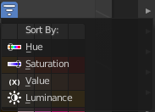
Sort By
Sort the palette by the chosen method.

Brush Settings Panel - Advanced Sub panel
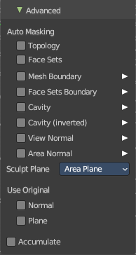
In this sub panel you can find the not so often used settings. They differ from brush to brush. Have a look at the tool tips.

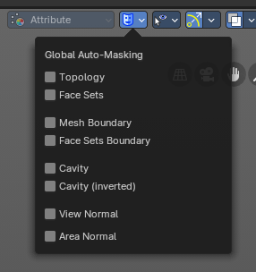
Global Automasking (Header)
In this sub panel in the header you can define Auto-Masking for scene brush settings.
Note: These override any brush Auto-Masking settings.

Automasking
In this group of properties toggles you can define Auto-Masking settings per brush. These are

Topology
Affect only vertices that are connected to the current active vertex under the brush.

Face Sets
Affect only vertices that share face sets with the active vertex.

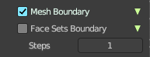
Mesh Boundary
Do not affect non manifold boundary edges.
The setting that appears on activation and is valid for both, Mesh Boundary and Face Sets Boundary.

Face Sets Boundary
Do not affect vertices that belong to a face set boundary.
The setting that appears on activation and is valid for both, Mesh Boundary and Face Sets Boundary.

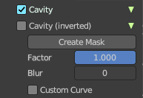
Cavity
Do not affect vertices on peaks. This feature is based on the surface curvature.
The setting that appears on activation and is valid for both, Cavity, and Cavity (Inverted).

Cavity (Inverted)
Do not affect vertices in valleys. This feature is based on the surface curvature.
The setting that appears on activation and is valid for both, Cavity, and Cavity (Inverted).

Create Mask
Creates a mask based on the curvature of the surface.

Factor
The contrast of the cavity mask.

Blur
The number of times the cavity mask is blurred

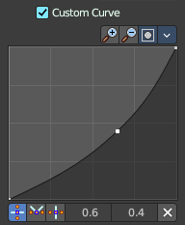
Custom Curve
Use a custom falloff curve for the cavity mask.


Selecting Points
You can select curve points. This reveals two edit boxes for the x and y coordinate of this point.
Selected points can be moved around. Left click at them, hold the mouse button down and move them to a new location.


Adding Points
You can add new curve points by simply left clicking at the curve. Move the mouse to position them where you need it.

Navigation elements
The navigation elements at the top are described from left to right.

Zoom in and out
The two buttons with the magnifying glass at it zooms in and out in the curve window.

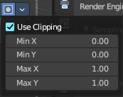
Clipping Options
Set up clipping for the stroke.

Use Clipping
Turns clipping on or off.

Min and Max X Y
The values for the clipping area.

Tools
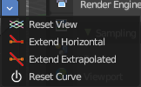
Tools is a menu where you can find some curve related tools.

Reset View
Resets the curve windows zoom.

Extend horizontal
Extends the curve before the first curve point and after the last curve point horizontally.

Extend extrapolated
Extends the curve before the first curve point and after the last curve point extrapolated.

Reset Curve
Resets the curve to the initial shape.

Handle Types
Sets the handle type for the current selected curve point.

X Y Position
The position of the current active curve point.

Delete Points
Deletes the current active curve point.

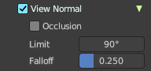
View Normal
Affect only vertices with a normal that faces the viewer.

Occlusion
Only affect vertices that are not occluded by other faces. With Occlusion on the Limit and Falloff options are not available.

Limit
View normal limit. The range of angles that will be affected.

Falloff
Extend the angular range with a falloff gradient.

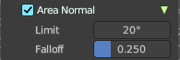
Area Normal
Affect only vertices with a similar normal to where the stroke starts.

Limit
Area normal limit. The range of angles that will be affected.

Falloff
Extend the angular range with a falloff gradient.

Sculpt Plane
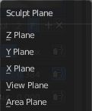
The sculpt plane defines how the sculpting is aligned. It is a dropdown box. Choose different methods. By default the Area Plane gets used.

Use Original

Normal
When ticked keep using normal of the surface where the stroke was initiated.

Plane
When ticked keep using plane origin of the surface where the stroke was initiated.

Accumulate
Accumulate stroke daubts on top of each other.

Front Faces Only
The brush only affects the vertices that faces the viewer. Projected Falloff Only.

Brush Settings Panel - Texture Subpanel
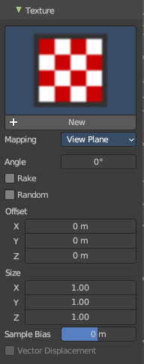
The Texture panel allows you to sculpt with textures. This allows you for example to grab a foto from some fish scales, and simply sculpt them into the surface of your object by using this image as a pencil. Or as a blueprint where you calk through ( Stencil method ).
Note that the following shots are made with Symmetry off and without Brush falloff. Since they disturbed.

Symmetry can be turned off a few panels deeper in the Symmetry panel.

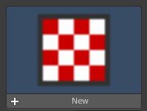
Browse Texture to be linked
The image at the top of the panel is a image browser. Choose a texture that you can choose for sculpting then. You can also have more than one image loaded at once.

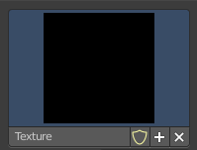
Adding a texture

The way to add the texture here is a bit more complicated. And not done with clicking at the New button.
First click at the New button below the image. This will create a new texture slot. This slot is still empty, it displays black.
We need to load the texture in this slot. This must be done in the Properties editor in the Textures tab.
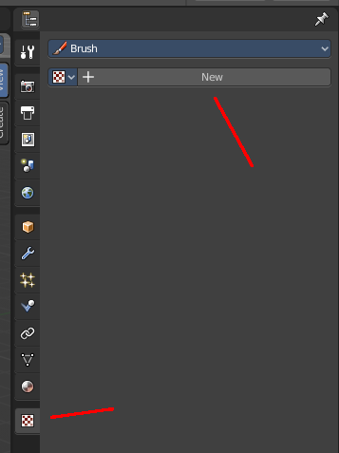
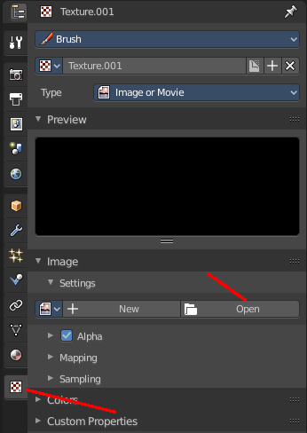
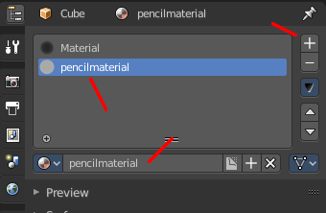
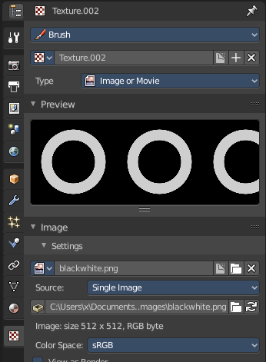

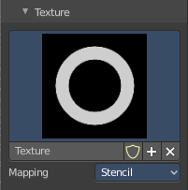
And when you switch back to the Tools tab, then the texture finally shows in the Texture panel in the Tool Shelf. And we can use it.

Texture Edit box
The Texture edit box is the edit box below the Image browser. When there's no image loaded then it displays the New button. When there's a image (or more) loaded, then you will see the name of the current texture.
The Fake User button turns this texture into a data block with a fake user. Means it will exists even when there is no data connected to it anymore.
The + Button adds another texture slot. Note that you will have to load a texture too, as explained above.
The X button deletes the texture slot.

Brush Mapping
Our texture can be mapped in different methods. The Brush mapping is a drop down box. Choose this different brush mapping methods.
The settings vary. So we will go through them by the different brush mapping methods.

Brush Mapping with mapping method View Plane and Area Plane
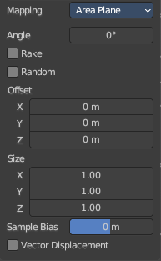
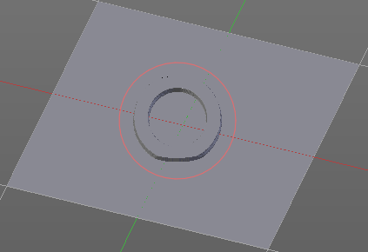
The brush mapping method View Plane maps the brush onto the surface of the object, calculating the mapping from the current view. The result may be distorted when the view does not align with the surface of the object.
The brush mapping method Area Plane maps the brush onto the surface of the object, calculating the mapping from the current view. The result is not distorted.

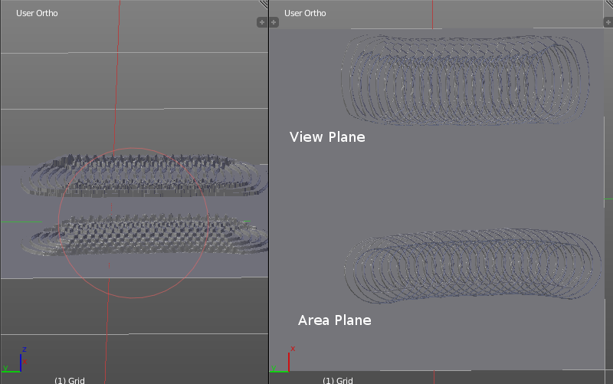
Angle edit box
Adjust the angle of the brush.

Rake
The angle follows the direction of the brush stroke.

Random
The brush angle gets set random.

Random edit box
Becomes visible when you tick Random. Adjust the maximum value of the random angle.

Offset
Fine tune the offset of the texture in the brush.

Size
Fine tune the size of the texture in the brush.

Sample Bias
Add to or subtract from the amount that gets added by the brush texture.

Vector Displacement
Just Area Plane. Handles each pixel color as an individual vector for displacement.

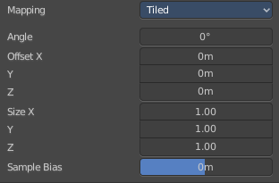
Brush Mapping with mapping method Tiled
The brush mapping method View Plane maps the brush onto the surface of the object, and tiles the pencil onto the surface. The mapping happens from the View plane. Means you get distortions when you sculpt from an angle.
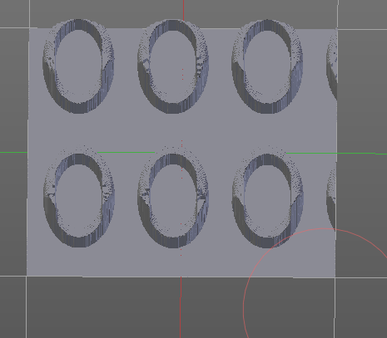

Angle edit box
Adjust the angle of the brush.

Offset
Fine tune the offset of the texture in the brush.

Size
Fine tune the size of the texture in the brush.

Sample Bias
Add to or subtract from the amount that gets added by the brush texture.

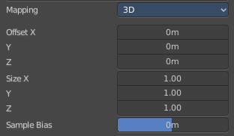
Brush Mapping with mapping method 3D
The brush mapping method View Plane and Area Plane sculpts where the pencil is. The method 3D sculpts at the initial position of the pencil, as long as you don't release the mouse. The mapping happens from the View plane. Means you get distortions when you sculpt from an angle.

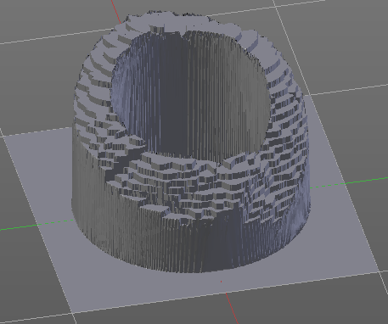
Offset
Fine tune the offset of the texture in the brush.

Size
Fine tune the size of the texture in the brush.

Sample Bias
Add to or subtract from the amount that gets added by the brush texture.

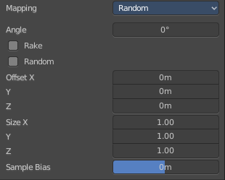
Brush Mapping with mapping method Random
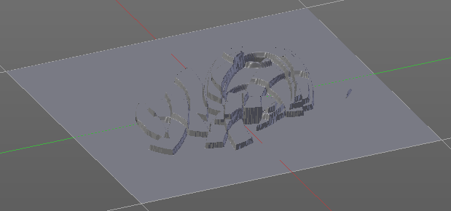
The brush mapping method Random randomizes the texture position of the pencil texture. And so it sculpts random fragments of the pencil.

Angle edit box
Adjust the angle of the brush.

Rake
The angle follows the direction of the brush stroke.

Random
The brush angle gets set random.

Random edit box
Becomes visible when you tick Random. Adjust the maximum value of the random angle.

Offset
Fine tune the offset of the texture in the brush.

Size
Fine tune the size of the texture in the brush.

Sample Bias
Add to or subtract from the amount that gets added by the brush texture.

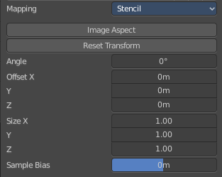
Brush Mapping with mapping method Stencil
The former methods uses the textures for the brush. The method Stencil works different. You have your texture displayed in the workspace above the object, and you paint this texture onto your object with your pencil strokes.
Note that the texture in the 3d space is just visible when you are with the mouse over the viewport.
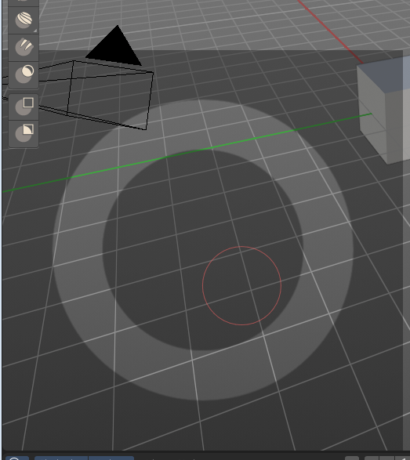

Image Aspect
Adjust the stencil size to fit to the image aspect ratio.

Angle edit box
Adjust the angle of the brush. The button at the end allows you to set the radius by dragging the mouse. This should be done in the viewport and with the hotkey. This button is just a visible reminder.

Offset
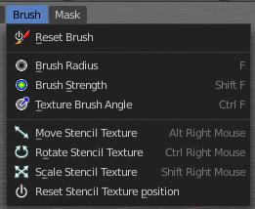
Fine tune the offset of the texture in the brush.

Stencil Texture Controls
You can find the controls to modify the position, rotation and scale of the stencil texture in the Brush menu in the 3D view. This happens by Hotkeys.

Brush Settings Panel - Stroke Sub panel
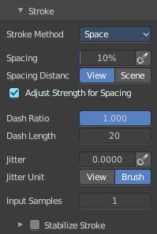
The Stroke panel contains settings to influence the behavior of the brush stroke. There are various stroke methods available. We will go through them one by one.

Stroke Panel with Stroke method Space
This is the default Stroke method. The sculpt stroke gets added continuously with given settings.
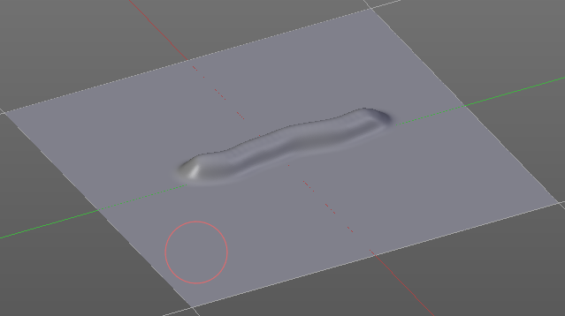

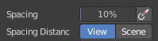
Spacing Edit Box
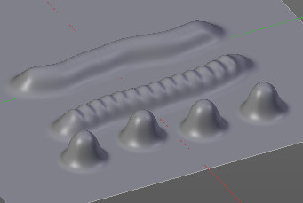
The sculpt drawing happens by mapping the pencil onto the mouse position. And when you move the mouse then the next mapping happens. Adjust the spacing after what mouse movement the next mapping should happen. The lower the value, the lower the distance between the single dots.

Spacing Pressure
The icon behind the edit box enables tablet pressure sensitivity for tablets.

Spacing Distance
If the spacing happens in View or in Scene distance.

Adjust Strength for Spacing
Automatically adjust the strength to give consistent results for different spacing.

Dash Ratio
Ratio of samples in a cycle that the brush is enabled.

Dash Length
Length of a dash cycle measured in stroke samples.

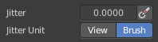
Jitter Edit Box
Add Jitter to the brush while painting.

Jitter Pressure
The icon behind the edit box enables tablet pressure sensitivity for tablets.

Jitter Unit
If the jitter happens in screen space in pixels, or relative to the brush size.

Input Samples Edit Box
Average multiple input samples together to smooth the brush stroke.

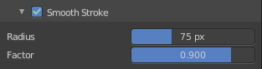
Stabilize Stroke
When activated then the brush lags behind the mouse position, and produces a much smoother stroke by that. It is a sub panel with two settings.

Smooth Stroke Radius Edit Box
Adjust the radius of the smoothing.

Smooth Stroke Factor Edit Box
Adjust the factor of the smoothing.

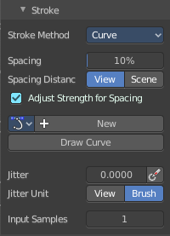
Stroke Panel with Stroke method Curve
The Stroke method curve doesn't simply influence the way how the stroke is painted.
It is a special method. First you draw a curve object by holding down ctrl and clicking with left mouse button. Then you tweak the curve. You can click at the curve point, and drag out handlers to make the curve points smooth.
Then you hit the Draw Curve button. And the curve gets sculpted.

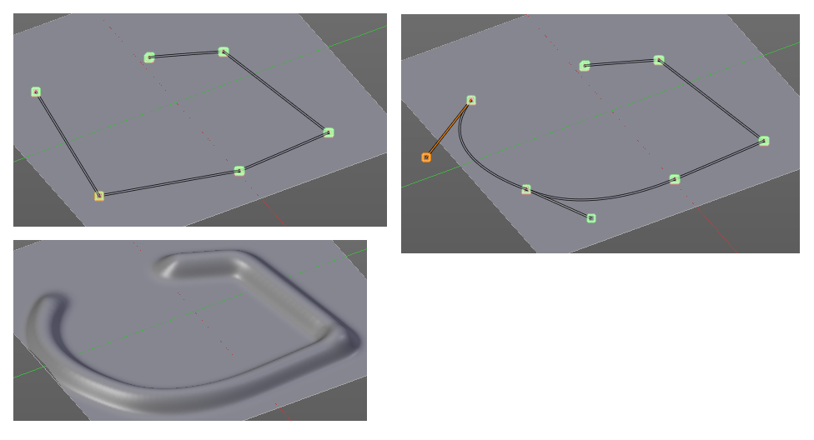

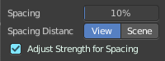
Spacing Edit Box
The sculpt drawing happens by mapping the pencil onto the mouse position. And when you move the mouse then the next mapping happens. Adjust the spacing after what mouse movement the next mapping should happen. The lower the value, the lower the distance between the single dots.
The icon behind the edit box enables tablet pressure sensitivity for tablets.

Spacing Distance
If the spacing happens in View or in Scene distance.

Adjust Strength for Spacing
Automatically adjust the strength to give consistent results for different spacing.

Paint Curve edit box
Here you set the active curve.
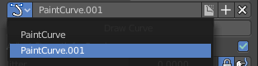
The first element is a drop down box where you will find your curves objects. You can have more than one.
The second element is the edit box that displays the active curve.
Fake User set the brush to have a fake user. Zero user data-blocks are normally not saved. But sometimes you want to force the data to be kept even when the data block has no user.
The + button allows you to add a new pencil with the current settings. Note that the brushes are NOT saved when you close Bforartists. You can save them into the current blend file. Or you can save the startup file. But be careful here. This saves everything else of the current state of Bforartists too.
The X button deletes the brush as the active one. It does NOT delete it from the brushes list.

Draw Curve Button
A click at it to turns the curve into a sculpt stroke.

Jitter Edit Box
Add Jitter to the brush while painting.

Jitter Pressure
The icon behind the edit box enables tablet pressure sensitivity for tablets.

Jitter Unit
If the jitter happens in screen space in pixels, or relative to the brush size.

Input Samples Edit Box
Average multiple input samples together to smooth the brush stroke.

Stroke Panel with Stroke method Line
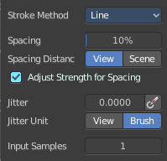
With Stroke method line you draw a line between a starting point and an endpoint. And when you release the mouse then the line gets sculpted.

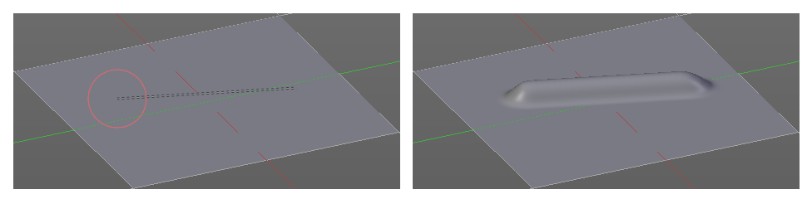

Spacing Edit Box
The sculpt drawing happens by mapping the pencil onto the mouse position. And when you move the mouse then the next mapping happens. Adjust the spacing after what mouse movement the next mapping should happen. The lower the value, the lower the distance between the single dots.
The icon behind the edit box enables tablet pressure sensitivity for tablets.

Spacing Distance
If the spacing happens in View or in Scene distance.

Adjust Strength for Spacing
Automatically adjust the strength to give consistent results for different spacing.

Jitter Edit Box
Add Jitter to the brush while painting.

Jitter Pressure
The icon behind the edit box enables tablet pressure sensitivity for tablets.

Jitter Unit
If the jitter happens in screen space in pixels, or relative to the brush size.

Input Samples Edit Box
Average multiple input samples together to smooth the brush stroke.

Stroke Panel with Stroke method Airbrush
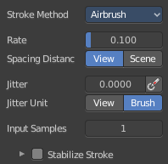
The sculpt stroke acts like an airbrush pencil. The dots gets placed randomly.
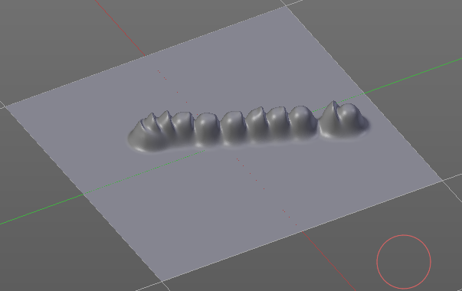

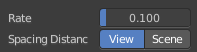
Rate Edit Box
Define the rate of the drawing.

Spacing Distance
If the spacing happens in View or in Scene distance.

Jitter Edit Box
Add Jitter to the brush while painting.

Jitter Pressure
The icon behind the edit box enables tablet pressure sensitivity for tablets.

Jitter Unit
If the jitter happens in screen space in pixels, or relative to the brush size.

Input Samples Edit Box
Average multiple input samples together to smooth the brush stroke.

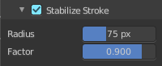
Stabilize Stroke
When activated then the brush lags behind the mouse position, and produces a much smoother stroke by that. Smooth stroke has two settings.

Smooth Stroke Radius Edit Box
Adjust the radius of the smoothing.

Smooth Stroke Factor Edit Box
Is just active when Smooth Stroke is activated. Adjust the factor of the smoothing.

Stroke Panel with Stroke method Anchored
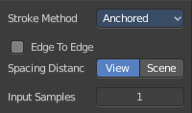
Click and drag to place a dot and to scale it.

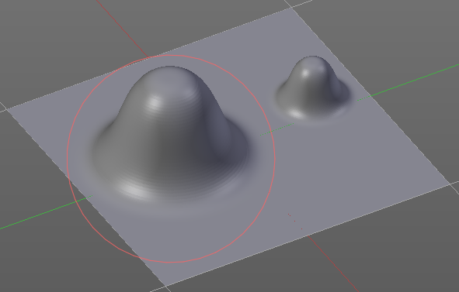

Edge to Edge
Without Edge to Edge the scaling happens from the center of the brush. With edge to edge the scaling happens from the edge of the brush.

Spacing Distance
If the spacing happens in View or in Scene distance.

Input Samples Edit Box
Average multiple input samples together to smooth the brush stroke.

Stroke Panel with Stroke method Drag dot
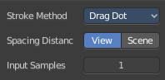
Click and drag to place a dot.

Spacing Distance
If the spacing happens in View or in Scene distance.
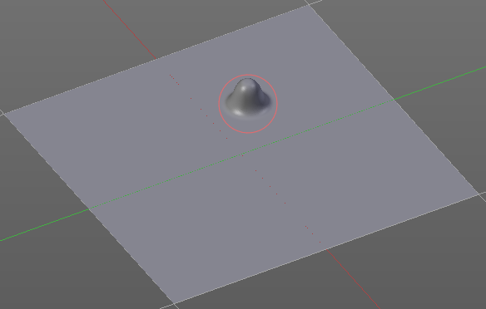

Input Samples Edit Box
Average multiple input samples together to smooth the brush stroke.

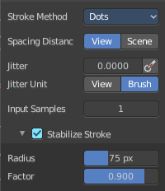
Stroke Panel with Stroke method dot
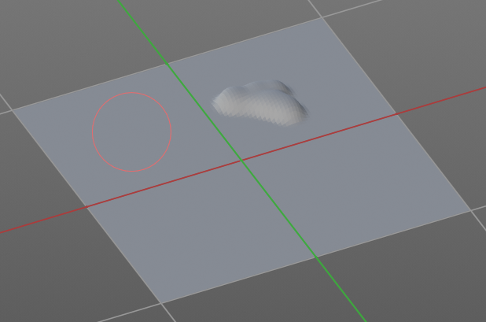

Spacing Distance
If the spacing happens in View or in Scene distance.

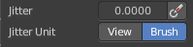
Jitter Edit Box
Add Jitter to the brush while painting.
The icon behind the edit box enables tablet pressure sensitivity for tablets.

Jitter Unit
Jitter in screen space or relative to the brush size.

Input Samples Edit Box
Average multiple input samples together to smooth the brush stroke.

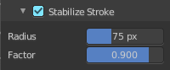
Stabilize Stroke
When activated then the brush lags behind the mouse position, and produces a much smoother stroke by that. Smooth stroke has two settings.

Smooth Stroke Radius Edit Box
Adjust the radius of the smoothing.

Smooth Stroke Factor Edit Box
Adjust the factor of the smoothing.

Brush Settings Panel - Falloff Sub panel
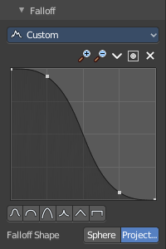
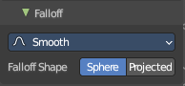
The Falloff panel allows you to define different falloffs methods for the border of the brush.

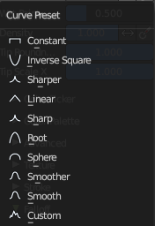
Presets
The different available falloff presets. The method custom allows you to define your own falloff. And reveals a curve panel.

Selecting Points
You can select curve points. This reveals two edit boxes for the x and y coordinate of this point.
Selected points can be moved around. Left click at them, hold the mouse button down and move them to a new location.

Adding Points
You can add new curve points by simply left clicking at the curve. Move the mouse to position them where you need it.

Navigation elements
The navigation elements at the top are described from left to right.

Zoom in and out
The two buttons with the magnifying glass at it zooms in and out in the curve window.

Tools
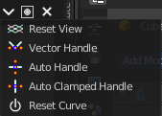
Tools is a menu where you can find some curve related tools.

Reset View
Resets the curve windows zoom.

Vector Handle
Set handle type to Vector.

Auto Handle
Set handle type to Auto.

Auto Clamped Handle
Set handle type to Auto Clamped.

Reset Curve
Resets the curve to the initial shape.


Use Clipping
Clipping options. Set up clipping for the stroke. The blue button at the top turns clipping on or off.

Delete Points
Deletes the selected curve point.


Curve Presets
Predefined curve presets as a starting point.

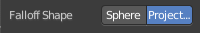
Falloff Shape
Use projected or spherical falloff.

Brush Settings Panel - Cursor Sub panel
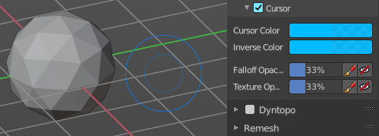
Change the appearance of the brush cursor.

Cursor checkbox in header
Show or hide the brush cursor.

Cursor Color
The cursor color with add operations.

Inverse Color
The cursor color with subtract operations.

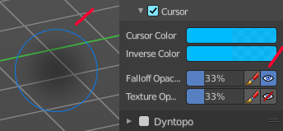
Falloff Opacity
You can turn on the cursor overlay with the eye button at the end. The falloff opacity slider allows you to adjust the opacity of this cursor overlay.

Override Overlay
Hide the Cursor Overlay when painting.

Use Cursor Overlay
Turn on Cursor Overlay.

Texture Opacity
This is for the case when you paint with a texture brush. You can turn on the Texture overlay with the eye button at the end. The falloff opacity slider allows you to adjust the opacity of this cursor overlay.

Override Overlay
Hide the Texture Overlay when painting.

Use Cursor Overlay
Turn on Texture Overlay.

Dyntopo Panel
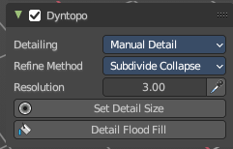
Dyntopo stands for Dynamic Topology Sculpting.
Without Dyntopo you just deform the existing geometry. With Dyntopo geometry gets subdivided when needed. This makes it possible to sculpt complex shapes out of a block.

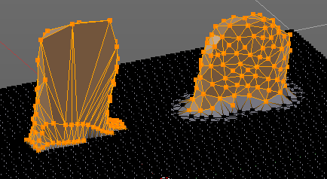
Left without Dyntopo, right with Dyntopo.
Note: Some brushes are incompatible with Dyntopo.
Brushes that are incompatible are the Grab brush, Rotate brush, Thumb brush, Layer brush, Smooth brush (including alt-key smoothing with a different brush) and Mask brush.
The topology will also not update if the stroke mode is Anchored or Drag Dot.

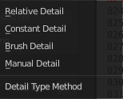
Detailing
Define the Detail Type method.

Relative Detail
Mesh Detail is relative to brush size and detail size

Brush Detail
Mesh Detail is relative to brush radius.

Constant Detail
Mesh detail is constant in object space according to detail size.

Manual Detail
Mesh detail does not change on each stroke. But just on flood fill

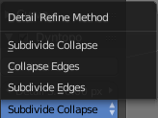
Refine method
Define the Detail refine method.

Subdivide Collapse
Both methods in one. Subdivide long edges to add mesh detail where needed. And collapse short edges to remove mesh detail where possible.

Collapse Edges
Collapse short edges to remove mesh detail where possible.

Subdivide Edges
Subdivide long edges to add mesh detail where needed.

Resolution
The Resolution defines how fine the subdivision will be.
The edit box below does the same. But with a slider, and without visible feedback in form of a widget.

Sample detail size picker
This pipette allows you to pick the current resolution from a mesh.
To activate the tool, hover with the mouse over the mesh and left click to apply.
Note: This work in the Constant and Manual methods exclusively.

Set Detail Size / Set Detail Percentage
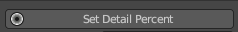
This button triggers the ability to set the detail size through a mouse overlay. This sets the mesh detail (either a relative or constant one, depending on current dyntopo mode).
To activate the tool, click on the button, drag the mouse left or right, then left click to apply.

Detail Flood Fill
This button fills the mesh with the selected detail setting.

Remesh Panel
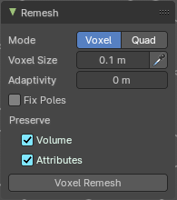
You may create a sculpt mesh that has ways too many polygons. Or too many polygons at one area, and not enough polygons at another area. Remeshing recreates the mesh geometry, with a more uniform topology.
Remesh does not work with Dyntopo enabled. You need to turn it off for remeshing.

Mode
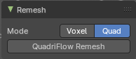
The Remesher in Sculpt mode uses the Voxel remesher by default. When you want to remesh with the Quadriflow method, then switch to Quad remesher. Quad remesher has no further options.

Voxel Size
Adjust the density of the new created geometry

Sample Detail Size
With this picker you can pick the density from an area of your mesh.

Adaptivity
Reduces the final face count by simplifying geometry where detail is not needed. This method uses tris. A value greater than 0 disables the Fix Poles feature.

Fix Poles
Produce less poles and a better topology flow.

Smooth Normals
Smooths the normals of the result.

Preserve

Volume
Tries to preserves the volume of the original mesh.

Attributes
Keep existing paint masks, face sets, vertex color and other generic mesh attributes on the new mesh.

Voxel Remesh / Quadriflow Remesh
Starts the remesh operation.

Symmetry Panel
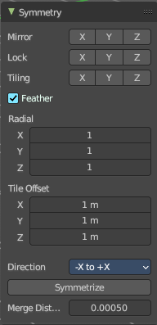
The Symmetry Lock panel contains tools around symmetry and lock features. Here you can turn on or off mirroring along axis, etc.

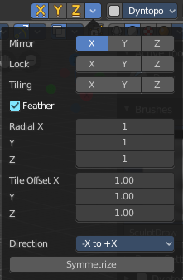
Mirror
Mirror sculpt along activated axis. By default the mirroring is activated around X axis.
The same buttons plus the whole Symmetry Lock Panel as a drop down menu can also be found in the tool settings bar as icon buttons. This allows quicker access and better visual control which mirror axis is currently active.

Lock
Disallow vertices movement in locked axis direction.

Tiling
Produces a mesh that is tilable in the activated directions.

Feather
Reduce the strength of the brush where it overlaps symmetrical daubs.

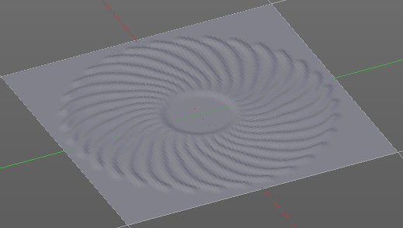
Radial
Adjust the repeating across some axis. For example, when you change Z to 32, then you can draw 32 segments simultaneously around the Z axis instead of
just one, distributed around the Z axis.

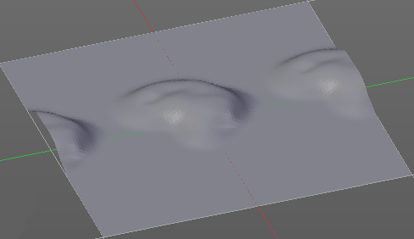
Tile Offset
Adjust the offset of the tiling.

Direction
The direction in which the mirroring happens.

Symmetrize
Symmetrize the topology modifications.

Merge Distance
The distance to merge vertices with symmetrizing.

Sculpt Mode - Options Panel

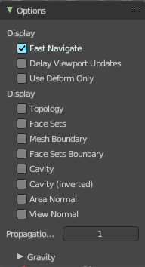
Display

Fast Navigate
For Multires, show Low Res mesh when navigating.

Delay Viewport Updates
Update the geometry when it enters the view. This enables a faster viewport navigation.

Use Deform only
Use only deformation modifiers ( The other constructive modifiers except multi-resolution gets temporary disabled)

Display

Topology
Affect only vertices connected to the active vertex under the brush.

Face Sets
Affect only vertices that share face sets with the active vertex.

Mesh Boundary
Do not affect non manifold boundary edges.

Face Sets Boundary
Do not affect vertices that belongs to a face set boundary.

Cavity
Do not affect vertices at the peaks. Based on the surface curvature.

Cavity ( Inverted)
Do not affect vertices in the valleys. Based on the surface curvature.

Area Normal
Affect only vertices with a similar normal to where the stroke starts.

View Normal
Affect only vertices with a normal that faces to the view.

Propagation Steps
Distance where boundary edge automasking is going to protect vertices from the fully masked edge.

Gravity sub panel
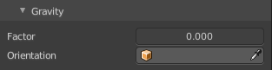
A panel with the gravity settings. Add gravity after each stroke.

Factor
The factor slider defines the amount.

Orientation
Here you define an object that gets used to determine the gravity from. The Z axis of this object gets used.

